

MA3920 PROFESSIONAL INTERNSHIP

Tan Yi Rong
U2320967K
School of Mechanical and Aerospace Engineering

Final Internship Report
Professional Internship / AY24-25

Acknowledgements
I would like to extend my deepest gratitude to Mr. Ng Christopher, my internship supervisor, for his unwavering support and guidance throughout the entire 20-week Professional Internship. His trust allowed me the autonomy to drive the OHT Sensor System project from its conceptual phase to a final, manufacturable design, which significantly enhanced my professional and technical development.
I am sincerely grateful to Mr. Ian Carlos Salazar (Lead) and Mr. Mark Joseph Atienza, Senior Associate Engineers in the AMHS department. They provided continuous, hands-on mentorship, especially during the critical design phases involving sensor testing and the pivot to a modular, cost-efficient solution. Their engineering feedback was instrumental in delivering a practical project deliverable.
Special thanks to Mr. Tay See Hong for his assistance in coordinating vendor communications and procurement logistics for the sensor mount fabrication. I also thank Mr. Tan Tiah Long for his earlier detailed tours of Fab 7, 7G and 7H, which provided the foundational context necessary for designing a cross-fab solution.
The entire AMHS team including Mr. Nay Tun Naing and Mr. Alan Ho, deserves recognition for their continuous support in navigating technical documentation and internal theories.
Finally, I thank all GlobalFoundries staff who contributed to my learning, including the Facilities team for the job shadow opportunity, all of which enriched my understanding of the broader semiconductor ecosystem.
Table of Contents
Acknowledgements 2
1. Introduction 4
1.1 Company Overview 4
1.2 Internship Department: AMHS Fab 7 5
1.3 Internship Scope 5
2. AMHS Background 6
2.1 What is AMHS and the Role of OHT System 6
3. Main Project: Sensor System for OHT Wheel Monitoring 7
3.1 Current Manual Maintenance Process 7
3.2 Identified Issues 7
3.3 Objective of Project 7
3.4 Project Outline 8
3.5 Design and Academic Application 9
4. Supporting Tasks: 10
4.1 Orientation and Induction Training 10
4.2 High Power Inductance Device (HID) Data Management 11
5. Reflections 12
6. Appendices 13
6.1 Appendix A – Sensor Comparison Table 13
6.2 Appendix B – Sensor Mount Ideation and Designing 14
6.3 Appendix C – HID Label Improvement Example (Censored) 16
6.4 Appendix D - FOUP Movement Log Format (Censored) 17

1. Introduction

1.1 Company Overview
GlobalFoundries (GF) is a leading global semiconductor foundry that provides advanced manufacturing services for integrated circuits. Operating on a pure-play foundry model, GF manufactures chips designed by other companies. The company fosters a culture of innovation, collaboration and continuous improvement, with a strong emphasis on safety, quality and operational excellence.
GF offers a wide range of semiconductor manufacturing technologies, including radio frequency (RF), analog and embedded memory solutions. Its services span from design enablement to wafer fabrication and testing. GF serves global markets, with key customers in automotive, mobile, IoT and data centre sectors. Suppliers include equipment manufacturers and raw materials providers while competitors include TSMC, Samsung Foundry, UMC and Intel.
GF’s competitive edge lies in its focus on specialised process technologies and advanced packaging. At the heart of its Asia-Pacific operations, GF Singapore (APAC headquarters) operates Fab GIGA+ and Fab 7, 7G and 7H, which manufacture chips on both 200mm and 300mm wafers, supporting technologies from 350nm to 40nm.
GF APAC also fosters a supportive and inclusive work environment that emphasizes both professional development and employee well-being. The company offers a variety of employee engagement initiatives, including additional training, weekly sports activities, cultural celebrations, and team bonding events. GF Singapore has also been recognized as the Employee Experience Champion of the Year at the 2025 Employee Experience Awards in Singapore, winning multiple awards for its excellence in leadership, learning, engagement, and talent acquisition.
In addition, GF Singapore supports talent development through paid internships, traineeships, and work-study programs in collaboration with local institutions. These initiatives provide hands-on experience in semiconductor manufacturing and open pathways to full-time employment, reinforcing GF’s commitment to nurturing future talent in the region.

1.2 Internship Department: AMHS Fab 7
During my internship, I was attached to GF APAC under the Automated Material Handling System (AMHS) department at Fab 7 as an automation equipment engineer. The department oversees the Overhead Hoist Transport (OHT) system, which automates the movement of Front Opening Unified Pods (FOUPs) which are known as wafer carriers between process tools in the cleanroom. This system plays a critical role in maintaining production efficiency and minimising contamination risks.

1.3 Internship Scope
The main objective of my internship project was to develop a sensor-based monitoring system that measures the condition of OHT wheels in real time. This system will allow for automated data collection for AMHS maintenance and support for predictive replacement of wheel components. By identifying wear and tear early, the system helps to reduce error occurrences and improve Mean Moves Between Interrupts (MMBI) during production runs, ultimately enhancing overall fab’s productivity and reliability.
In addition to the main project, I also supported the team with ad-hoc tasks during downtimes or urgent prioritise tasks such as checking High Power Inductance Device (HID) data and capturing images of machine labels for documentation for overhaul planning.

2. AMHS Background

2.1 What is AMHS and the Role of OHT System
The Automated Material Handling System (AMHS) is a vital infrastructure within the semiconductor fab that ensures the smooth and efficient movement of materials. It is responsible for transferring FOUPs (Front Opening Unified Pods), which carry wafers, between different process tools in a highly controlled cleanroom environment. AMHS helps reduce manual handling, minimises contamination risk, and improves production flow.
One of the key components of the AMHS is the Overhead Hoist Transport (OHT) system. These are rail-guided vehicles that run on tracks suspended from the ceiling. OHTs pick up and deliver FOUPs based on instructions from the Material Control System (MCS). Because wafers are extremely sensitive to particles, vibrations, and delays, OHTs must operate with high accuracy and reliability. Any fault or downtime in the OHT system can disrupt the production schedule and reduce overall fab efficiency.
To support daily operations and ensure accountability, I attended the AMHS department's 8:00 AM daily passdown meetings. These meetings reviewed the previous day's Preventive Maintenance (PM) and Corrective Maintenance (CM) activities on the OHT systems. Line support engineers reported the specific issues encountered during their shifts, allowing for accountability when a repaired OHT returns with further issues. This detailed tracking ensures that the engineer who performed the previous maintenance can be identified and consulted, promoting responsibility and transparency in maintenance activities. These updates are used by senior engineers to document maintenance history in the AMHS data system and to identify any components that require urgent replacement or restocking.
The meeting also provided visibility on the total OHT utilization for Fab 7, 7G and 7H enabling trend analysis. Anomalies in utilization rates can affect overall production, as reduced OHT activity may indicate delays or inefficiencies in wafer transport. Additionally, AMHS oversees not only OHTs but also stockers, which function as storage systems for both empty and loaded FOUPs awaiting pickup. The performance of both systems contributes to the smooth operation of the fab.
The maintenance and performance of OHTs are critical to achieving high FOUPs move and meeting fab productivity goals. That is why improvements to OHT monitoring such as predictive maintenance systems, are important for reducing errors and unplanned downtimes in wafer transport operations.

3. Main Project: Sensor System for OHT Wheel Monitoring

3.1 Problem Description and Project Rationale
The project addresses the unreliability of the current manual maintenance process used to check OHT wheel wear. Technicians currently use a vernier caliper to measure wheel diameter, a method highly susceptible to human error. Small inconsistencies in pressure or measurement angle lead to inaccurate and inconsistent data, evidenced by impossible readings (like diameter appearing to increase over time), rendering the collected information unreliable.
This data inconsistency is critical because excessive wheel wear causes the OHT vehicle to lean slightly. Even this minor angle deviation, particularly given the height differences involved, can disrupt the FOUP look-down sensor's alignment. This misalignment frequently causes failed pick-ups or transport delays, requiring the OHT to repeatedly readjust its position. Such issues disrupt wafer flow, reduce fab efficiency, and highlight the urgent need for a more reliable, automated detection system.

3.2 Project Objectives and My Role
To address these shortcomings, the AMHS department aims to implement an automated system using sensors to obtain highly accurate and consistent measurements. The core objective is to leverage this reliable data to integrate machine learning (ML) techniques for predicting the Remaining Useful Life (RUL) of the OHT wheels. This predictive maintenance approach will allow us to schedule maintenance proactively, thereby improving data integrity and minimizing unplanned downtimes.
My role in this project involves:
- Analyzing the current manual maintenance process.
- Identifying suitable sensor technologies.
- Developing a prototype system.
- Exploring predictive analytical models.

3.3 Project Outline and Current Status
The automated measurement system is being developed by a project team led by two senior associate engineers, Ian and Mark, and supported by myself. Our long-term goal is to replace the current manual measurements with an accurate, consistent sensor system and enable full predictive maintenance capabilities.
The project is currently in its first phase: ideation, sensor procurement, and prototype design. I began by conducting on-site observations of the OHT system and maintenance workflow. These observations were crucial for defining technical requirements, including necessary measurement precision, optimal sensor placement, and overall implementation feasibility within operational and environmental constraints.
We then held planning discussions and conducted research on suitable sensor technologies from vendors such as Keyence and Omron, evaluating options including ultrasonic, Light Detection and Ranging (LIDAR), and vision-based systems. After thoroughly evaluating factors like precision, compatibility, size, ease of integration, and cost, LIDAR was deemed the most cost-effective solution that still met our accuracy and integration requirements.
We developed proposal slides for our supervisor, Mr. Ng Christopher, to justify this selection, detailing the system's placement, expected precision, and implementation feasibility within the project timeline. These proposal materials are regularly updated to ensure project alignment and are intended to convince decision-makers of the project's value. Future iterations of the proposal will include a Return on Investment (ROI) analysis to highlight potential cost savings and long-term operational efficiency gains. (A sample of the sensor comparison table is provided in Appendix A, Figure A.1 for reference.)
Once the sensor is tested and validated, the next steps will involve collecting real-time data and comparing it with historical records to confirm accuracy. This validated dataset will serve as the foundation for training the machine learning model to predict wheel RUL. The final solution will include a dashboard or alert system to notify engineers when an OHT approaches its maintenance threshold.

3.4 Design and Academic Application
To support sensor mounting, I designed the mounting structure using CAD software, focusing on manufacturability and with accounts to the strict constraint of the location placement. This model also served as a reference when contacting manufacturers to request quotations for sensor mount fabrication.
To support this work:
- A sample of the measurement of the mount and placement is provided in Appendix B, Figure B.1.
- A sample of the ideation and designing of the sensor mount is provided in Appendix B, Figure B.2.
- A rough visualisation of sensor placement (LIDAR and future) is provided in Appendix B, Figure B.3.
- A conceptual design layout of the sensor mount structure, created in FreeCAD, is provided in Appendix B, Figure B.4.
The mechanical stability of the design will be validated using Free Body Diagram (FBD) calculations to ensure it can handle operational loads without failure. This step is intended to prevent any design flaws that could lead to remanufacturing or installation issues. The application of FBD analysis draws directly from my academic background in MA2001 Mechanics of Materials, while the ability to create detailed 3D models using CAD Software is a practical extension of what I learned in MA2005 Engineering Graphics through SolidWorks.
As this report covers progress up to Week 8, the CAD design and planning for FBD analysis represent the final steps in my current involvement. These tasks prepare the groundwork for the prototyping and testing phases that will continue during my Professional Internship (PI).
An additional challenge we identified is ensuring compatibility between the sensor system and the existing AMHS data infrastructure. Access to the OHT for installation and live testing will be crucial to validating the solution. Time constraints remain a key consideration as the remaining phases extend into the next internship cycle.

4. Supporting Tasks:

4.1 Cross-Functional Exposure
I learned about the factory's bigger picture by doing several job shadows and tours:
- Facilities Job Shadow: I saw how the whole infrastructure (like power and air supply) works under the OHT tracks. This helped me understand the space limits for my sensor design, especially near cable trays (Logbook 3).
- UMC Fab Tour: Visiting another company's factory showed me how their AMHS OHT systems were different in track layout and equipment. This helped me think more openly when designing my solution for GF (Logbook 4).
- CEO Q&A Session: I attended a session with the company's leaders and learned about their strategies for handling global trade and efficiency. This helped me understand how my work on the OHT system fits into the big company goals (Logbook 2).

4.2 OHT Brace Bar Bracket Redesign
I helped solve a problem with the OHT Brace Bar brackets. The original brackets kept breaking because they were made by bending a flat metal plate into a sharp 90° bend. The constant shaking and movement of the OHT created too much stress at this sharp corner, causing the bracket to fail.
My job was to design a solid replacement bracket. The key design fix was to make sure the new bracket was machined from a solid block of aluminum instead of being cut out into pieces and bend at specific parts. I also added a 3 mm radius curve (fillet) on the critical edges. This curve helps spread out the stress, making the new structure much stronger and stopping it from breaking under vibration. This task taught me how small design choices, like adding a curve, can fix big reliability problems.
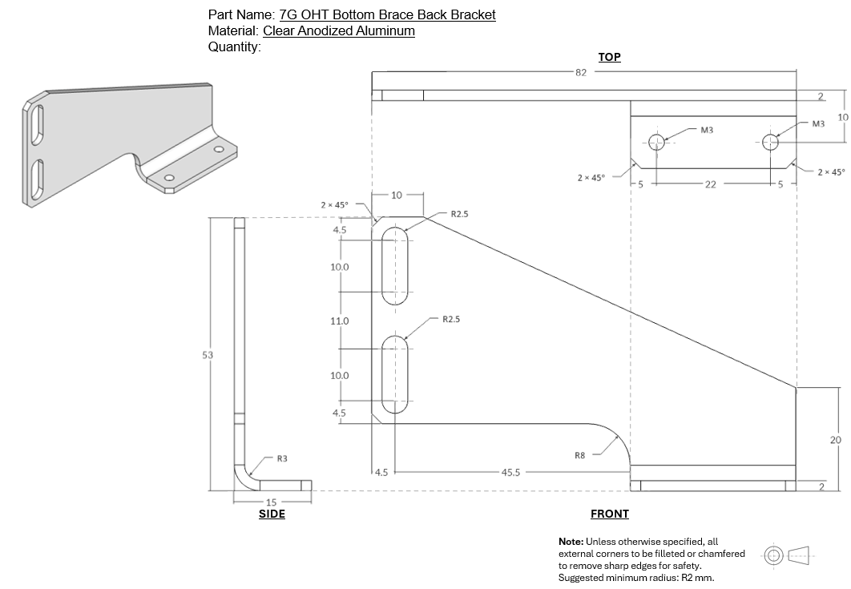
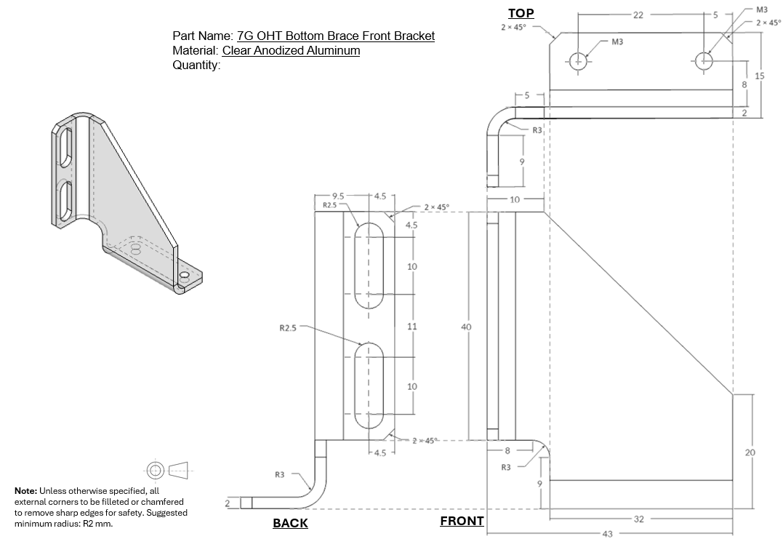

5. Reflections
This internship has been both demanding and rewarding. As a mechanical engineering student with no background in the semiconductor industry, stepping into GlobalFoundries was initially overwhelming. The cleanroom protocols, technical abbreviations and fab systems were all unfamiliar to me. However, the structured onboarding sessions, e-learning modules and on-the-ground training helped me adapt quickly. Over time, I grew more confident and became comfortable contributing to engineering discussions and tasks.
The highlight of my experience was supporting the development of an automated sensor system for monitoring OHT wheel wear. I participated in sensor evaluation, vendor coordination and proposal development. Applying what I had learned in MA2005 Engineering Graphics and MA2001 Mechanics of Materials, I designed a sensor mount in CAD software and prepared for FBD analysis to ensure structural reliability. I also helped draft proposal slides to justify sensor selection and align our approach with project goals. This process taught me how engineering knowledge translates into real-world design and project communication.
In addition to the main project, I handled side tasks such as validating HID data and relabeling over 240 HID units to improve traceability. I also tallied FOUP movement across OHTs to prioritise HID overhaul scheduling. These tasks, although tedious, gave me insight into how precise data handling supports fab operations. I learned that maintenance work, even at the data level has direct consequences on production uptime and scheduling.
Daily passdown meetings further helped me understand fab operations and the importance of accountability in maintenance activities. I saw how cross-shift communication, issue logging, and part ordering were managed efficiently. These sessions exposed me to the fast-paced, 24/7 nature of fab work and helped me appreciate the discipline and planning it requires.
As I progressed, I also began to understand the backend systems that keep the fab running such as the power supply infrastructure that energizes the OHT system and the MCS that determines the routing and destinations of each OHT. These systems operate silently in the background but are critical to the fab’s overall performance.
One key learning was how small mechanical issues, such as wheel wear and tear can cause the OHT to lean slightly to one side. This seemingly minor misalignment can significantly affect sensor detection accuracy especially since the FOUP pick-up sensor relies on precise distance and alignment. A deviation in sensor readings can lead to misdetection or failed pick-ups, which in turn disrupts wafer transport and causes delays. This experience helped me appreciate how small faults can snowball into larger disruptions across the production line, reinforcing the importance of proactive maintenance and system calibration.

6. Appendices
Note on Visuals: To comply with GlobalFoundries' confidentiality guidelines, visual materials such as CAD screenshots, internal data tables, or site-specific images have either been excluded or edited to remove any proprietary or sensitive content. Visual assets in this report are conceptual in nature and intended only to support general understanding of the project scope. Internal visuals are stored securely within the company’s internal systems and are available only to authorised personnel.

6.1 Appendix A – Sensor Comparison Table

